1. <!DOCTYPE html>

<html>

<head>

    <meta charset="utf-8">

    <title>Browser name and version</title>

</head>

<body>

    <script type="text/javascript">

        var name = "\n Browser Name: " + navigator.appName + '<br>';

        var version = "\n Browser Version: " + navigator.appVersion+'br';

        document.write(name);

        document.write(version);

    </script>

</body>

</html>

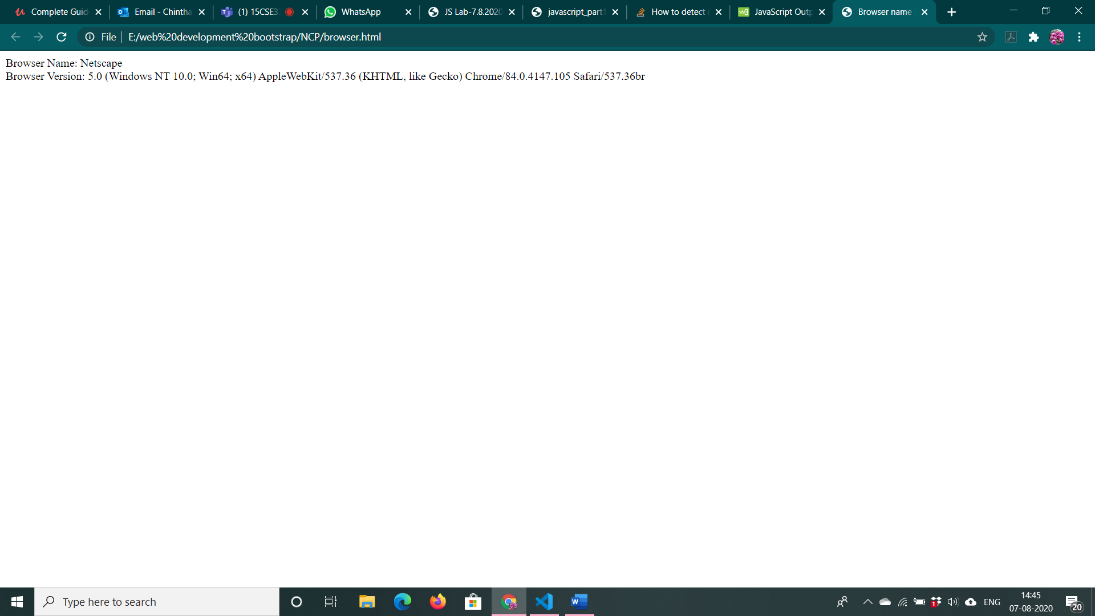

2. <!DOCTYPE html>

<html>

    <meta name="viewport" content="width=device-width, initial-scale=1">

<style>

.button {

  border-radius: 4px;

  background-color: #f4511e;

  border: none;

  color: #FFFFFF;

  text-align: center;

  font-size: 28px;

  padding: 20px;

  width: 200px;

  transition: all 0.5s;

  cursor: pointer;

  margin: 5px;

}

.button span {

  cursor: pointer;

  display: inline-block;

  position: relative;

  transition: 0.5s;

}

.button span:after {

  content: '\00bb';

  position: absolute;

  opacity: 0;

  top: 0;

  right: -20px;

  transition: 0.5s;

}

.button:hover span {

  padding-right: 25px;

}

.button:hover span:after {

  opacity: 1;

  right: 0;

}

</style>

<body>

    <h2>Click the Button to go to the Image</h2>

<button onClick="myFunction()" class="button"><span>CLICK </span></button>

<script>

    function myFunction(){

        location.replace("buttonimg.html")

    }

</script>

</body>

</html>

Buttonimg.html

<!DOCTYPE html>

<html>

    <body>

        <a href="https://www.shutterstock.com/category/nature"><img src="C:\Users\VENKATESHWARULU\Downloads\flow.JPG" width="50%" height="50%"

            onmouseout="document.body.style.backgroundColor ='gray'"

            onmouseover="document.body.style.backgroundColor ='green'" />

        </a>

    </body>

</html>

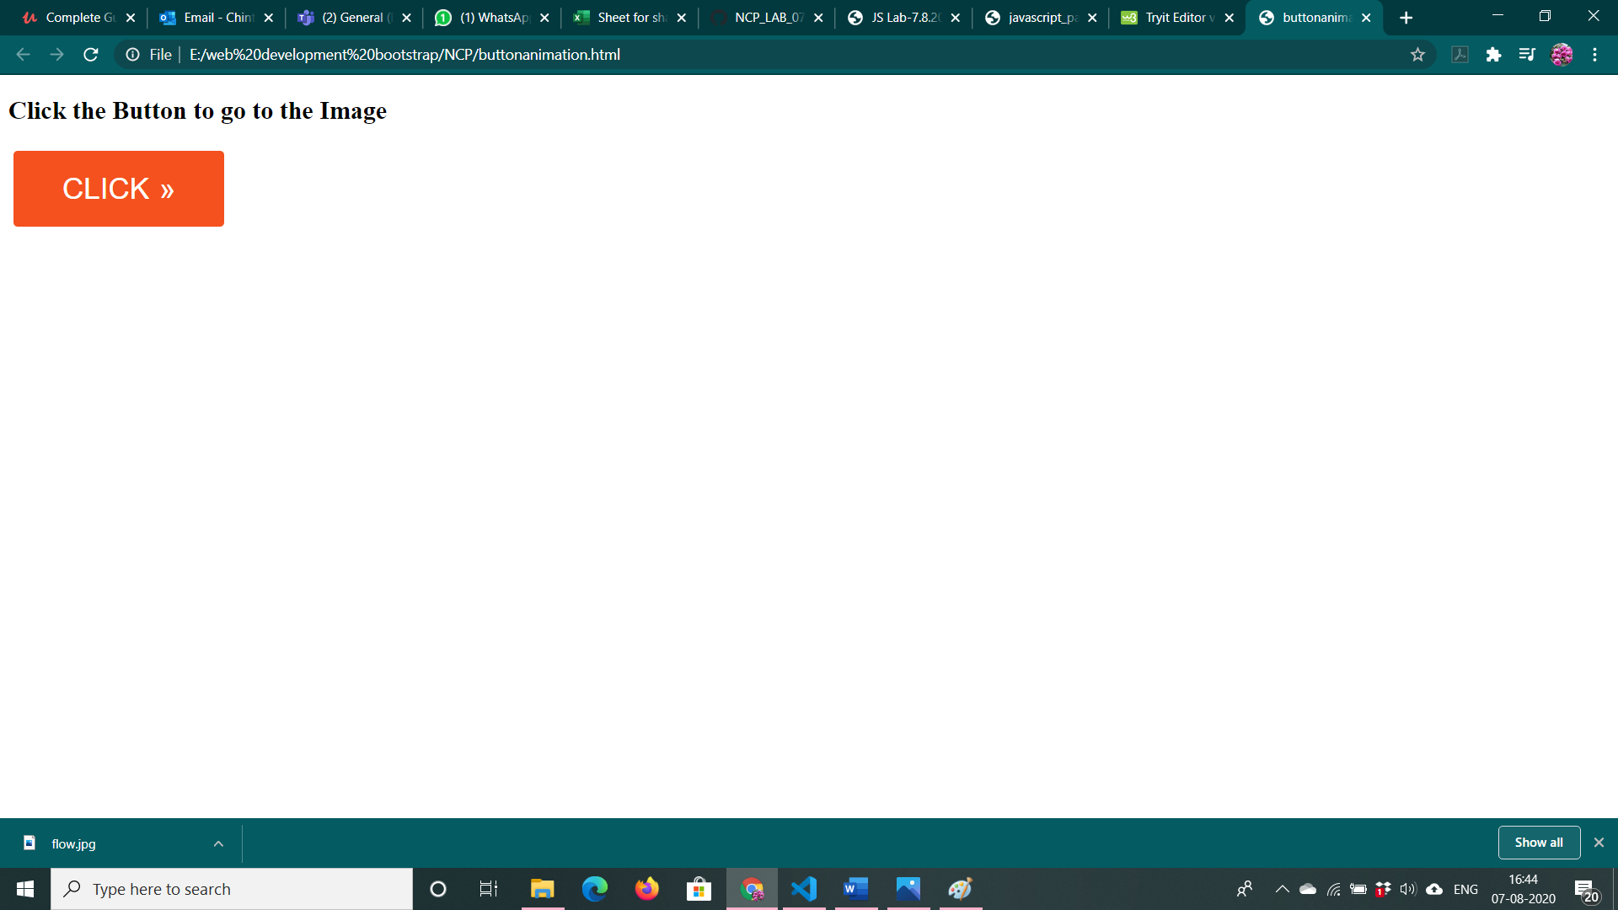

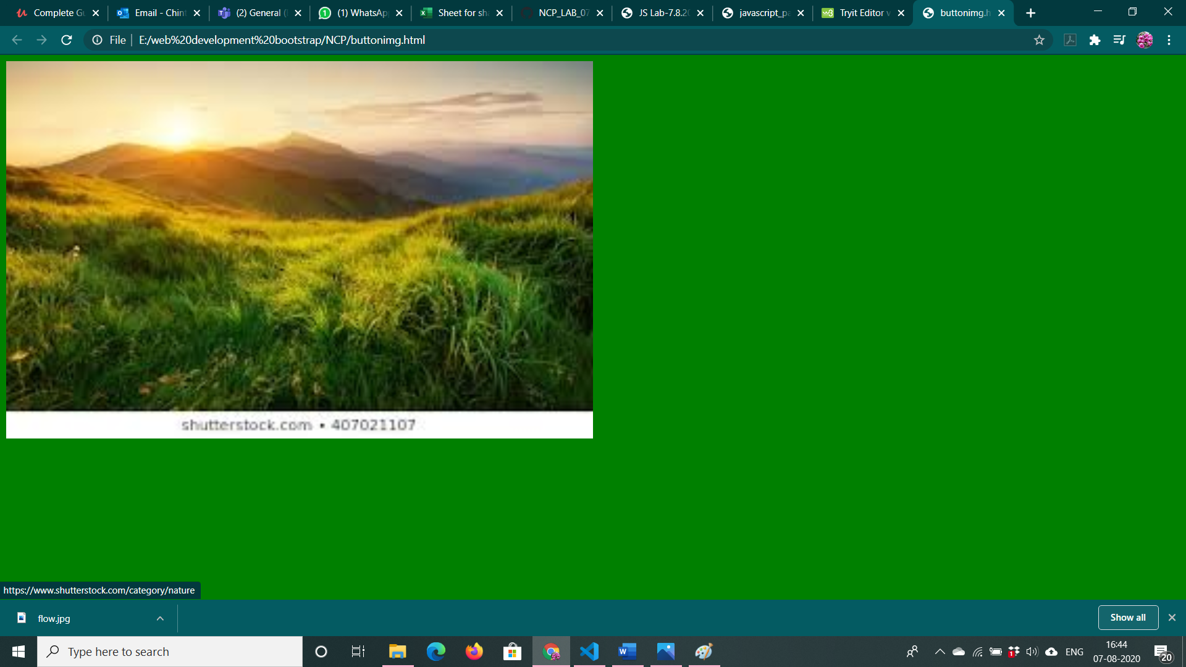

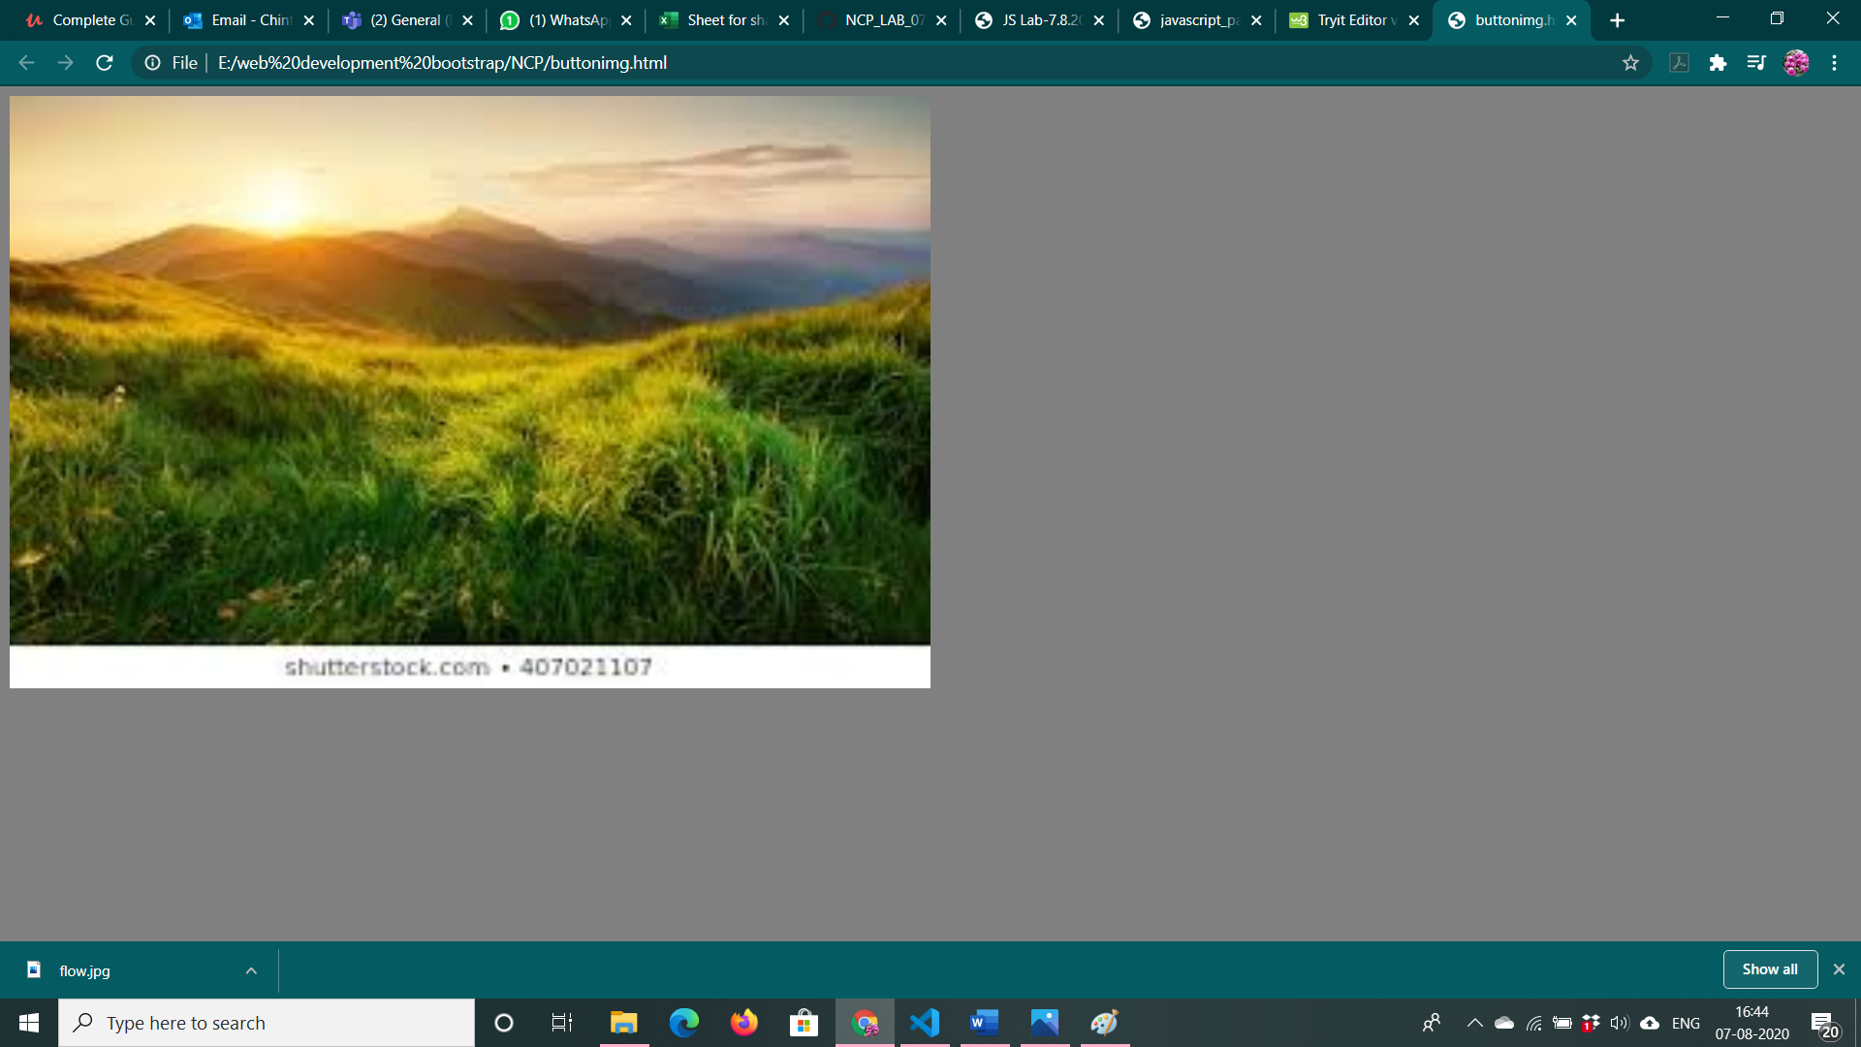

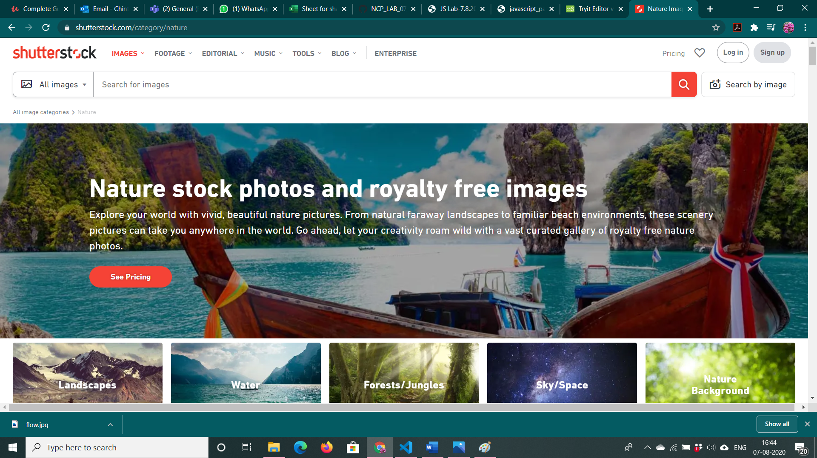

3. <!DOCTYPE html>

<html lang="en">

<head>

    <meta charset="UTF-8">

    <meta name="viewport" content="width=device-width, initial-scale=1.0">

</head>

<body>

    <img src="C:\Users\VENKATESHWARULU\Downloads\imgmaps.PNG" usemap="#map" >

    <map name="#map">

        <area shape="rect" coords="0,0,270,400" onmouseover="left()" onmouseout="out()" onclick="imageClick()">

        <area shape="rect" coords="270,0,550,406" onmouseover="right()" onmouseout="out()" onclick="imageClick()">

    </map>

    <p id="popup">Popup text will be displayed here</p>

</body>

<script>

    function left()

    {

        document.getElementById("popup").innerText="Left"

    }

    function right() {

        document.getElementById("popup").innerText = "Right"

    }

    out()

    {

        document.getElementById("popup").innerText= "Popup will be displayed here"

    }

    function imageClick()

    {

        window.open("enlarged.html")

    }

</script>

</html>

Enlarged.html

<!DOCTYPE html>

<html lang="en">

<head>

    <meta charset="UTF-8">

    <meta name="viewport" content="width=device-width, initial-scale=1.0">

    <title>Enlarged</title>

</head>

<body>

    <img src="C:\Users\VENKATESHWARULU\Downloads\imgmaps.PNG" alt="" height="1000px" width="1000px">

</body>

</html>

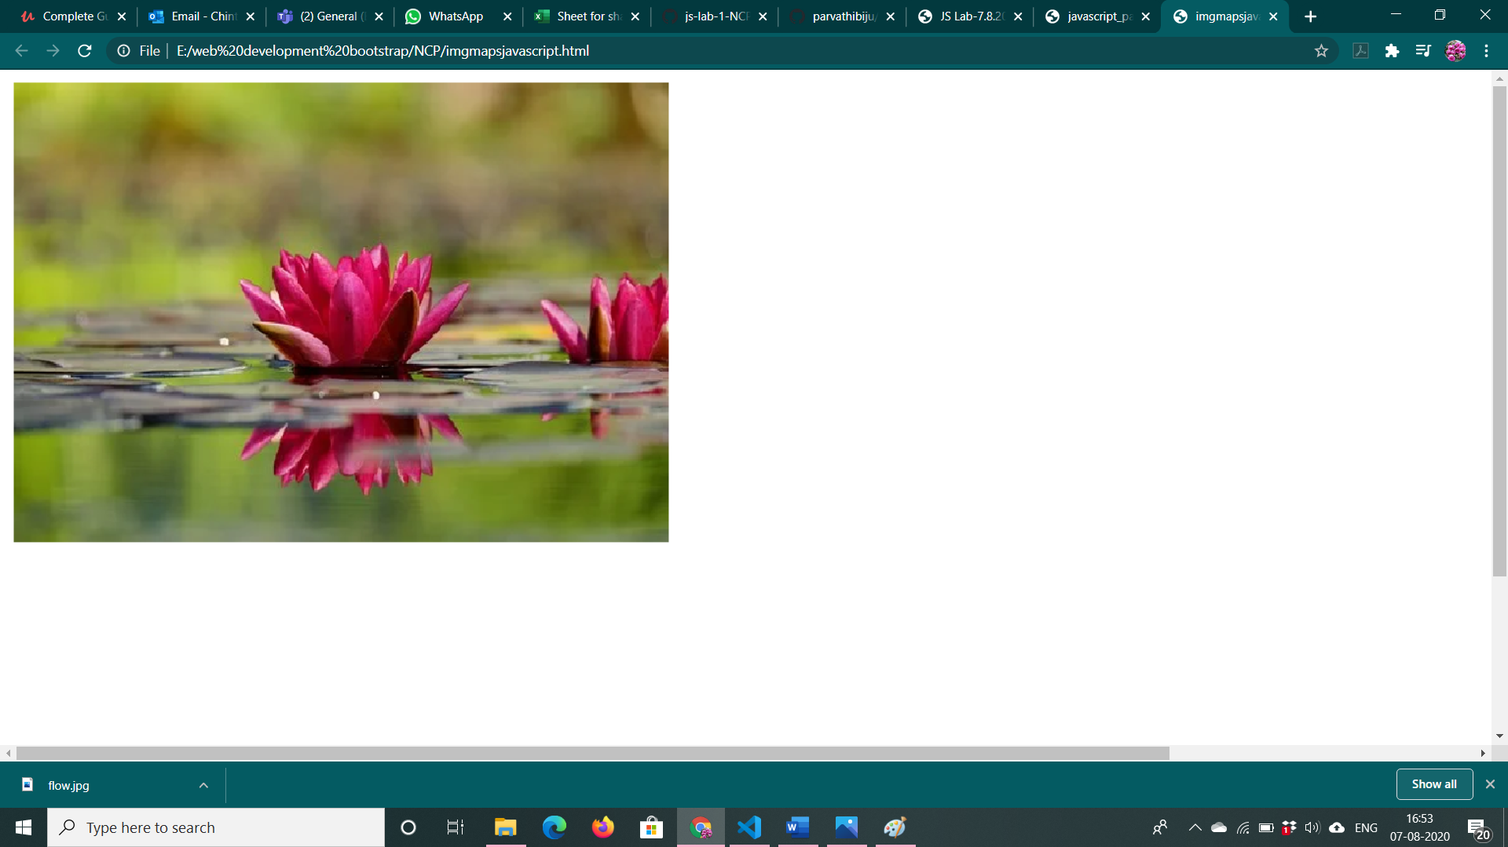

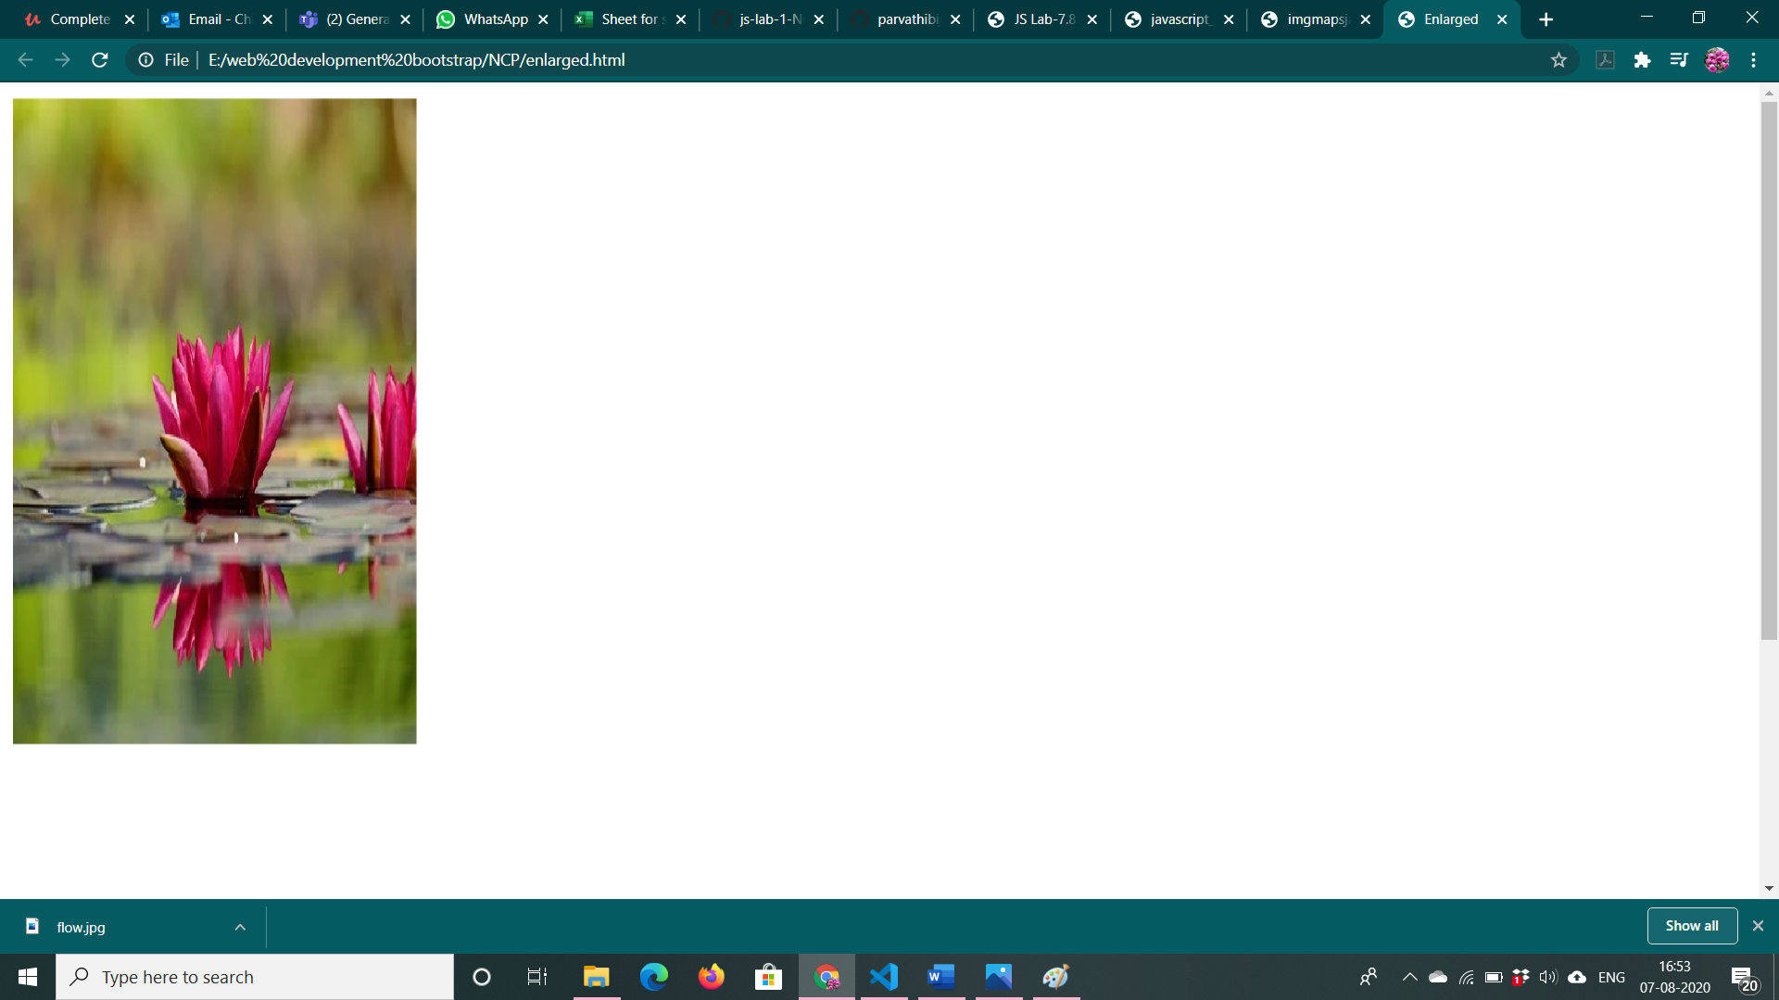

4. <!DOCTYPE html>

<html>

<script type="text/javascript">

    function fibonacci() {

        var n1 = 0,

            n2 = 1,

            n3, i, count;

        count = prompt("enter count to find fibanocci series");

        for (i = 2; i < count; ++i) {

            n3 = n1 + n2;

            document.write(" " + n3);

            n1 = n2;

            n2 = n3;

        }

    }

</script>

<body>

    <input type="button" value="click to find fibanocci series" onClick="fibonacci()"/>

</body>

</html>

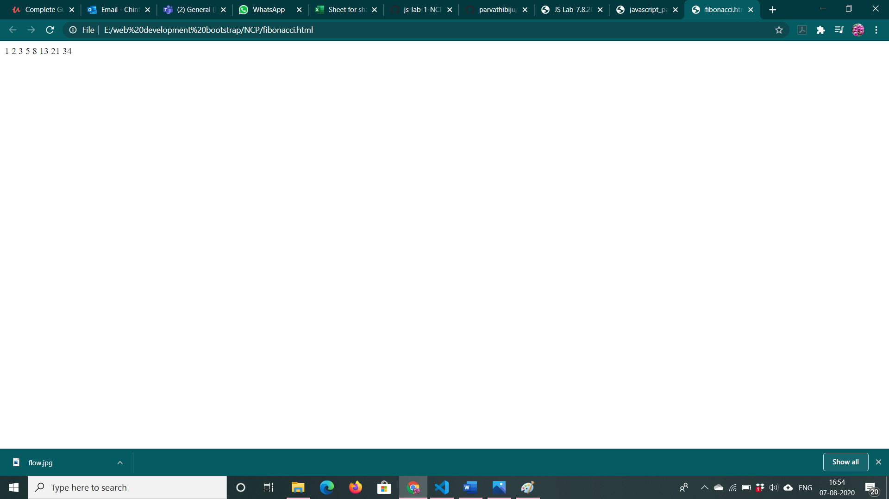

5. <!DOCTYPE html>

<html lang="en">

<head>

    <meta charset="UTF-8">

    <meta name="viewport" content="width=device-width, initial-scale=1.0">

    <title>Question 5</title>

</head>

<body>

    <input type="text" name="name" id="name">

    <input type="submit" id="submit" onclick="clickResponse()">

</body>

<script>

    var arr=[]

    var input = document.getElementById("name");

        input.addEventListener("keyup", function (event) {

            if (event.keyCode === 13) {

                event.preventDefault();

                arr.push(document.getElementById("name").value)

                document.getElementById("name").value=""

            }

        });

    function clickResponse()

    {

        arr.sort()

        alert(arr)

    }

</script>

</html>

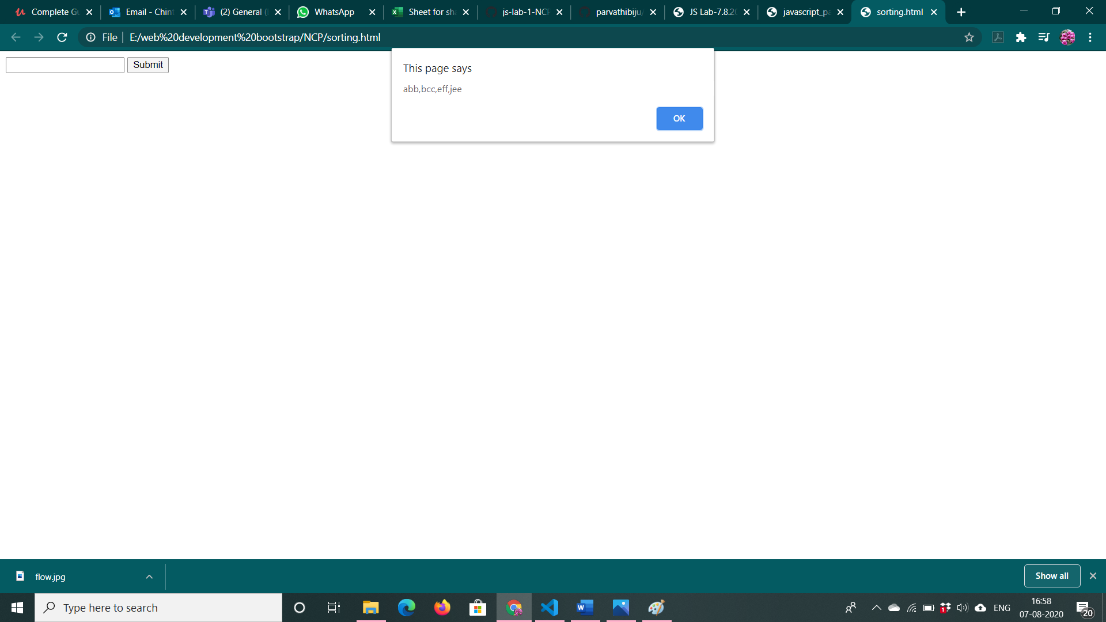

6. <!DOCTYPE html>

<html>

    <script type=text/javascript>

    function simple_interest(){

    var p,r,t;

    p=prompt("Enter principle");

    t=prompt("Enter time");

    r=prompt("Enter rate");

    var simpleinterest = (p*t*r)/100;

    document.write("Simple interest:"+simpleinterest);

}

    </script>

    <body>

        <input type="button" value="give the values for getting simple interest" onClick="simple_interest()"/>

    </body>

</html>

